# COMPANY PROFILE

## Company Name : EZ Trainings and Technologies Pvt.Ltd.

### Introduction:

EZ Trainings and Technologies Pvt. Ltd. is a dynamic and innovative organization dedicated to providing comprehensive training solutions and expert development services. Established with a vision to bridge the gap between academic learning and industry requirements, we specialize in college trainings for students, focusing on preparing them for successful placements. Additionally, we excel in undertaking development projects, leveraging cutting-edge technologies to bring ideas to life.

### Mission:

Our mission is to empower the next generation of professionals by imparting relevant skills and knowledge through specialized training programs. We strive to be a catalyst in the career growth of students and contribute to the technological advancement of businesses through our development projects.

### Services:

**College Trainings:**

* Tailored training programs designed to enhance the employability of students.
* Industry-aligned curriculum covering technical and soft skills.
* Placement assistance and career guidance.

### Development Projects:

* End-to-end development services, from ideation to execution.
* Expertise in diverse technologies and frameworks.
* Custom solutions to meet specific business needs.

**Locations:** Hyderabad | Delhi NCR

At EZ Trainings and Technologies Pvt. Ltd., we believe in transforming potential into excellence

**Internship Program on Python for BE-3rd Sem students**

**From 15th April to 4th May 2024 (During 3rd semester vacations).**

**Student Name: Bhavana Joshi USN No: 3BR22AI025 Branch: AIML**

|  |  |  |  |
| --- | --- | --- | --- |
| **INDEX PAGE** | | | |
| **Day** | **Date** | **Content Covered** | **Signature of the** |
| **faculty in-charge** |
| **1** | **15.04.24** | **Introduction to python, conditional & control statements, programs on leap year, prime number, GCD, LCM** |  |
| **2** | **16.04.24** | **Find reverse of number, multiply and add all digits in number, palindrome, even & odd number, factorial, fibonacci** |  |
| **3** | **17.04.24** | **Functions, datatypes, MCQ’s** |  |
| **4** | **18.04.24** | **List, programs based on list** |  |
| **5** | **19.04.24** | **Strings & recursion and based programs** |  |
| **6** | **20.04.24** | **OOPS concept** |  |
| **7** | **22.04.24** | **Searching & sorting (linear & binary search, bubble, selection & insertion sort)** |  |
| **8** | **23.04.24** | **Merge & quick sort, stacks & queues** |  |
| **9** | **24.04.24** | **Linked list** |  |
| **10** | **25.04.24** | **Trees** |  |
| **11** | **26.04.24** | **Graph** |  |
| **12** | **27.04.24** | **Project preparation** |  |
| **13** | **28.04.24** | **Project preparation** |  |
| **14** | **29.04.24** | **Project preparation** |  |
| **15** | **30.04.24** | **Project preparation** |  |
| **16** | **02.05.24** | **Project preparation** |  |
| **17** | **03.05.24** | **Presentation day** |  |
| **18** | **04.05.24** | **Presentation day** |  |

## ABSTRACT

## The Championship History Tracker is a comprehensive web-based application designed to document, analyze, and celebrate the rich legacy of championship competitions across various sports and disciplines.

## Key features of the Championship History Tracker include CRUD (Create, Read, Update, Delete) operations for managing championship records, user authentication and authorization for controlling access to features and data, search and filter functionality for navigating through championship history, and interactive visualizations for presenting data in a visually appealing and informative manner.

* The tracker allows users to explore past championship events, track winners and runners, analyze historical trends and performances, and generate statistics and insights.

* With its mobile-friendly design, customization options, and extensibility features, the Championship History Tracker serves as a valuable resource for sports enthusiast , journalists, and organizations to honor and celebrate the achievements teams in the world of sports.

## INTRODUCTION OF THE PROJECT

## Sports championships have a rich history filled with memorable moments, legendary performances, and iconic rivalries.

## Whether it's cricket's prestigious ICC Cricket World Cup, basketball's thrilling NBA Finals, or any other sporting event, championships serve as the pinnacle of athletic competition.

## However, keeping track of championship history, including winners, runner-ups, and key details, can be challenging, especially as the number of championships across different sports continues to grow.

## To address this need, we introduce the Championship History Tracker, a comprehensive solution designed to manage and explore historical data related to sports championships.

## The Championship History Tracker provides users with a user-friendly interface to navigate through championship records, view detailed information about past events, and analyze trends and statistics.

## MODULE DESCRIPTION

* A championship history tracker is a software tool designed to store, manage, and display information about past championships in various sports or competitions. It allows users to track the winners, runners-up, and other relevant details of championships over time. Here's a description of the key features and components typically found in a championship history tracker:
* Data Storage: The tracker stores championship data in a structured format, including details such as the name of the championship, year, winner, runner-up, and possibly other relevant information (e.g., venue, MVP).
* User Interface: The tracker provides a user-friendly interface for users to interact with championship data. This interface may include options to view championship history, search for specific championships, filter data based on criteria (e.g., year, sport), and perform other actions.
* CRUD Operations: The tracker supports CRUD (Create, Read, Update, Delete) operations to manage championship data. Users can add new championships, edit existing records, remove outdated information, and retrieve championship details as needed.
* Search and Filter: Users can search for specific championships or filter data based on different criteria, such as the year of the championship, the name of the sport, the country/region, etc. This functionality allows users to quickly find relevant information from the database.
* Visualization: The tracker may include visualization tools to present championship data in a visually appealing and informative manner. This could include charts, graphs, maps, or other visualizations to highlight trends, patterns, and statistics related to championship history.
* Multi-Sport Support: The tracker may support multiple sports or competitions, allowing users to track championships across different sports or games. This flexibility ensures that users can use the tracker for various purposes, whether it's tracking football championships, cricket tournaments, basketball leagues, or other events.
* Customization Options: Users may have the ability to customize the tracker according to their preferences. This could include options to personalize the user interface, configure display settings, or adjust data fields based on specific requirements.
* Security and Access Control: The tracker may implement security measures to protect championship data and ensure that only authorized users have access to certain features or data. This could involve user authentication, role-based access control, and other security mechanisms to safeguard sensitive information.
* Overall, a championship history tracker serves as a valuable tool for sports enthusiasts, historians, journalists, and others interested in exploring and analyzing the rich history of sports competitions around the world. It provides a centralized repository of championship data, making it easier to track and analyze past events, celebrate achievements, and preserve the legacy of sporting excellence.

## ALGORITHM

* Import Libraries:

Import the pandas library as pd for data manipulation.

Import the tkinter library for creating the graphical user interface (GUI).

Import the ThemedStyle class from the ttkthemes module for applying themes to the GUI.

Import the messagebox module from tkinter for displaying message boxes.

* Define Functions:
* read_championship_data(championship_data):

Define a function to read championship data from a CSV file.

Try to read the CSV file using pd.read_csv.

If the file is not found, display an error message using message box. show error and return an empty Data Frame.

* read_player_data(player_data):

Define a function to read player data from a CSV file.

Try to read the CSV file using pd.read_csv.

If the file is not found, display an error message using messagebox.showerror and return None.

* view_championship_details():

Define a function to view championship details based on user input.

Get the selected sport, category, and year from the GUI widgets.

Determine the appropriate championship data based on the selected sport.

Check if the championship data is not empty and if the entered year exists in the data.

If details are found for the specified year and category, display them using messagebox.showinfo.

If no details are found, display a message indicating so.

* search_player():

Define a function to search for player details based on user input.

Get the player name entered by the user from the GUI widget.

Iterate over the rows of the player data DataFrame.

If the player name matches, construct a string with the player details.

If the player is not found or player data is not loaded, display appropriate messages using messagebox.showinfo.

* Load Data:

Use the defined functions to read championship data for cricket and basketball from CSV files.

Use the defined function to read player data from a CSV file.

* Create GUI:

Create the main window (root) using tkinter.

Apply the "equilux" theme to the GUI using ThemedStyle.

Add labels, option menus, entry widgets, and buttons to the GUI for user interaction.

* Event Handling:

Define the actions to be performed when the user interacts with the GUI widgets:

When the "View Details" button is clicked, call the view_championship_details function.

When the "Search Player" button is clicked, call the search_player function.

* Main loop:

Start the GUI event loop using root.mainloop() to handle user interactions

**OUTPUTS:**

**WEBSITE PAGE:**

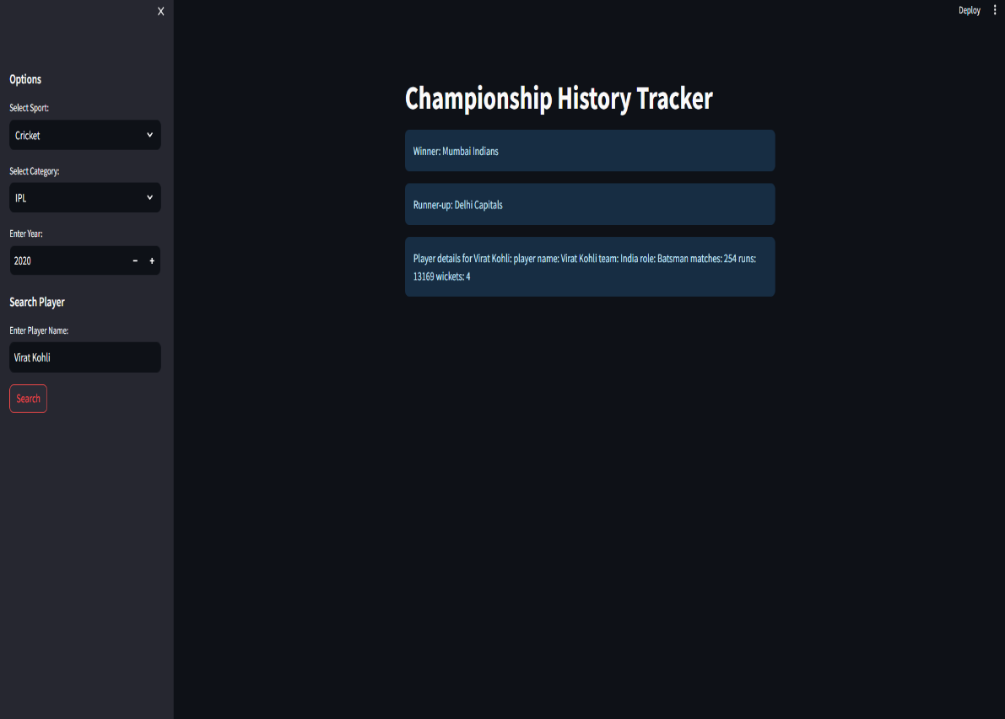

In conclusion, a championship history tracker serves as a valuable tool for sports enthusiasts, historians, journalists, and organizations to document, analyze, and celebrate the rich legacy of championship competitions across various sports and disciplines. By providing a centralized repository of championship data, the tracker enables users to explore past events, track winners and runners-up, and gain insights into historical trends and performances.

With features such as CRUD operations, database integration, user authentication, and search/filter functionality, the tracker offers a robust platform for managing championship records efficiently. Additionally, interactive visualizations, historical statistics, and API integration enhance the user experience and enable deeper analysis of championship history.

By embracing mobile-friendly design principles, customization options, and extensibility features, the tracker caters to the diverse needs and preferences of its users. Whether it's for personal enjoyment, academic research, sports journalism, or organizational purposes, a championship history tracker serves as a valuable resource for preserving and sharing the stories of sporting excellence and achievement.

Overall, the championship history tracker plays a vital role in honoring the athletes, teams, and moments that have shaped the world of sports, fostering a deeper appreciation for the passion, dedication, and spirit of competition that define the essence of championship events.

#### https://chat.openai.com/c/fd7b734f-d486-4848-9fe2-1e3b8045facc

* **google**

#### Microsoft Bing